Background

Problem

Goals

Success Metrics

Key Features & Scope

Core UX Flow

Total Addressable Market

Competitors

Acquisition Channel

Marketing Guide

Pricing Strategy

Pre-Launch Check List

Risk and Mitigation

Training Guide

User Guide

Launch Email

Post-Launch

### Background

Industries demand a change of the traditional education to increase technical skills on the graduates due to the development of new technologies. Also, COVID 19 has accelerated this necessity. In consequence, the increase of unemployment rates specially for the recent college graduates.

### Problem

According to recent statistics, approximately 39 million students and graduates are members of LinkedIn and 45% of recent graduates use it as their primary job search platform. Also, there isn’t any platform that does both training and placement. Our solution is a platform that gives students control and visibility of their professional growth in a well-known professional community such as LinkedIn.

### Goals

* Build an UX friendly app for a young community focus on the autonomy of GLinkedIn
* Reduce the time of getting the recommendations (jobs and trainings) according to the necessities of the market
* Offer exclusive partnerships that offer entry level jobs
* Partnering with Colleges around the world also with technical platforms

### Key Features

|  |  |  |
| --- | --- | --- |
| P0 | Reminders | Users should have reminders about the deadline for applications or training. It should be remembered that the cell phone is a means of distraction and we compete with many other apps. |
| P1 | Recommendations based on preferences | The algorithms created must give the user the accurate recommendations based on their background and preferences. |
| P2 | Trainings with certifications | For users, it is important that they do so to be awarded, that is why considering the certificates for them is essential. |
| P2 | Time tracking of mentor’s responses | Users want to know about how long the interaction with the mentor is and how long it will be given. They don’t want a bot's response. |

### Success Metrics

|  |  |  |  |
| --- | --- | --- | --- |
|  | Goals | Signals | Metrics |
| Happiness | Getting a first entry level job  Efficient guidance | Good feedback  Refer to friends/juniors  Students scoring well in skill test  Good feedback | Rating above 4.5  Number of app downloads  Mark he/she got in test  Rating above 3 |
| Engagement | App downloads  Training completion | Dashboard statistics (e.g., Searches for app in the store)  Added a training | Number of downloads  Average time spends on a training  Number of applicants |
| Adoption | Marketing | Social media publicity, publicity in online communities | Referral signup rate  Total views, Click-Through Rate |
| Retention | Interaction with users | Push notifications  In-app messaging | CTR, Open rates |
| Task Success | Users getting familiar with the app | Skipping Intros and How to do’s  Queries regarding how to use the app | Click rates of skip during intro’s  Reduced number of questions |

### Target Market

### Final year college students

* College universities
* Enterprises
* Startups

### Core UX Flow *(optional)*

[Prototype](https://www.figma.com/proto/EYysGtTjFgnXNp8n4370Zy/GLinkedin-%2F-Rocio-Castro?node-id=29%3A2&scaling=scale-down&page-id=0%3A1&starting-point-node-id=29%3A2)

### Total Addressable Market

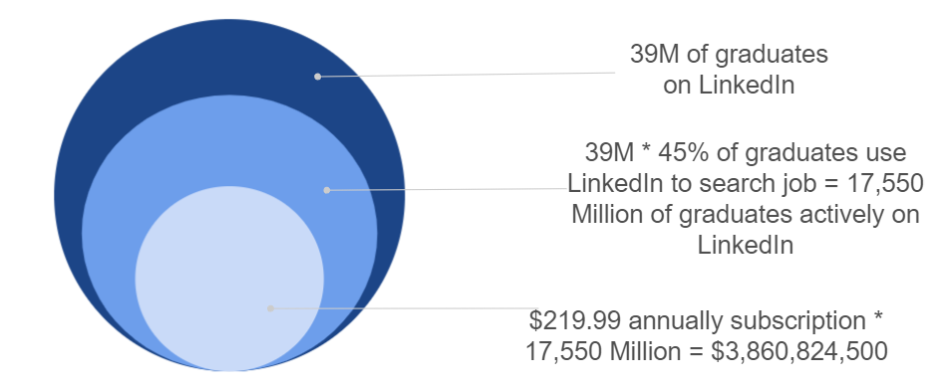

### Competitors

**Glassdoor**

* Glassdoor is an American website where you can find review companies. Also allows users to anonymously submit and view salaries as well as search and apply for jobs on its platform
* 58 million active users per month[1]
* 11 million active jobs listed[2]

**AIESEC**

* AIESEC is a non-governmental not-for-profit organization which let young people to explore and develop their leadership potential with an international job experience with leadership organizations
* 7 000 organizations + 120 countries + 36 000 international experiences[3]

### Acquisition Channel

**Awareness:**  
Nowadays digital platforms are a must on an acquisition channel strategy. Especially when we are planning the launching of a platform part of LinkedIn which is the most popular networking social media for professionals.

**Social Media Marketing**

Social media is a great way to build a community and get feedback from users who wouldn’t be incentivized to contact you in-app. Content will be focus on blog entries, competitions, discussion threads and user-generated content. Creating new, exciting, and relevant content is a highly effective way to snag your audience’s attention and send them to the app.

In the case of writing content, we are going to use:

SEO optimization

Search engine optimization is the process of growing the quality and quantity of website traffic by increasing the visibility of a website or a web page to users of a web search engine.

* 81% of people use search engines to do their homework before doing a big purchase
* 64% of Internet users depend on search engines to decide whether to buy something or not

**Influencer Marketing**

Influencer marketing is the use of influencers to reach new users and promote your brand. This is why is important to consider influencers as part of GlinkedIn brand strategy. Influencers who can reach the main target and are based on LinkedIn, Instagram and Tik Tok would be the best candidates for this strategy.

**Paid Digital Campaigns**

This strategy focusses on bring new users to the app through paid ads. Also, with this strategy we can build a retribution model to see the best performing channels. For example, LinkedIn Ads have a strong reach and some powerful targeting options. 605.4 million people can be reached through LinkedIn advertisements in general.

### [Marketing Guide](https://docs.google.com/document/d/1MeTo5a4_tOOdZgvrflfxNbFc8ro79b8H/edit?usp=sharing&ouid=108322001484836891103&rtpof=true&sd=true)

### Pricing Strategy

#### Revenue Goal

In TAM, we know that 17,5M of graduates are using LinkedIn as their first platform when they search for a job. In the first year, we want to get to 30% of these users.

|  |  |  |  |
| --- | --- | --- | --- |
| Segment | **Students** | **One Hiring** | **Volume Hiring** |
| Total Number of Clients | 3,510,000 | 2,000,000 | 1,000,000 |
| Revenue per client | $219.99 | 79.99 | 149.99 |
| Total revenue | $772,164,900 | $159,980,000 | $149,990,000 |

### 

## GlinkedIn has 3 premium plans for each market. While the main focus is on students, we wanted to create premium features also for small businesses and enterprises based on their hiring requirements.

Students can access the app with a limited version, and also try one month of free access to the premium plan. For small businesses and enterprises, there are 2 plans focused on automatization of the hiring process and giving them the chance to save time and money getting the right prospect for them.



**Students**

$219.99 yearly

*$28.33/month*

**One hiring**

$79.99

monthly

**Volume hiring**

$149.99

monthly

### Following parameters are used to measure that we have reached the revenue goal:

### Business KPIs: Revenue, Subscriptions

### Product KPIs: Downloads in App Store and Google Play Store, App Rating

### Revenue strategy

We offer free registration for students and a free trial for the premium plan for 1 month.

Subscription Freemium model:

* Students with a premium account will be eligible to get up to 4 mentors per year and will have access to all of the expert lead courses.
* On the other hand, students using unpaid accounts will be eligible to experience premium membership for 1 month and even after that, they get access to some courses.

### Pre-Launch Checklist

* Sales  
  Reach out to enterprises and startups to give a detailed explanation about the offering
* Customer Service  
  To help with students with questions and issues about the platform
* PR Consultant  
  To write release notes   
  To write blogs and content creation

### Anticipate and Plan for Risks

#### Risk factor:

* Engineering - If the system could handle the extra pressure of the market expansion.
* Marketing - A global product launch will require a big-budget marketing campaign to be rolled out across different regions. One potential risk is our message coming across as insensitive to local cultures, often due to improper translation.
* Testing - Will the new language rightly align with the user interface?
* Sustainability - If the product launch exceeds expectations, the team should be able to handle it.

Mitigation Plan:

* Internal testing can be done with the QA team and the back-end engineers to make sure the developed system would be able to handle the market expansion
* We can hire credible firms to ensure your promotional messages and branding appeal to the people in the region to deliver personalized fashion as they embrace our product
* Testing the UI before launch and during development to make sure the new languages are rightly aligned with the UI.
* The team should be ready to accept success and failures, and most importantly, ready to expand as the product grows. The success of a product can be measured by taking the feedback after the initial week of release.

### [Training Guide for Sales and Customer Support](https://docs.google.com/document/d/1h7e2cAI_ndeczFqwbfEO7MCMy-WKsteT/edit?usp=sharing&ouid=108322001484836891103&rtpof=true&sd=true)

### [User Guide](https://docs.google.com/document/d/1UXlu6Snkw0Jqu9UsiYCS9TLLkRGH-8GM/edit?usp=sharing&ouid=108322001484836891103&rtpof=true&sd=true)

### [Launch Email](https://docs.google.com/document/d/1wr7fkRu48ZSCEmieavGiPXLIi3bAsxNe/edit?usp=sharing&ouid=108322001484836891103&rtpof=true&sd=true)

### Post-Launch

#### Solution

After launching our product, the adoption rate is lower than expected by about 35%. Following method can be introduced to increase the adoption rate:

* Refer a friend: Introducing a friend feature within the app. With this feature, users could share the referral code to a friend and can create a room to study together if both users have a GlinkedIn account. The goal is to keep the students motivated. Adopting this method would increase both retention and adoption rates.
* Hackathons: Most students participating in hackathons are college students. Therefore, associating/conducting a hackathon would increase the visibility of the platform.

The student partner program will motivate the enrolled students themselves and his/her fellow college mates as well.

Key Metrics:

* Click through rate greater than or equal to 20%
* More than 15% sign ups during hackathon
* 1M+ unique monthly visitors

Control and Variant:

* Users in the control group will have the same features itself
* Users in the variant group will have the access to refer a friend feature and learning classrooms

### The call for participants for the hackathon will be a general call and all the premium students can apply to the Student Partnering program.

### Hypothesis:

### Our users with the feature of referring a friend will increase the learning classrooms and hence increase the adoption rate. Reaching out to students via hackathons and student partner programs will bring in new users to the platform.

1. https://www.similarweb.com/website/glassdoor.com/
2. https://www.glassdoor.com/blog/guide/how-to-use-glassdoor/#:~:text=With%20over%2045%20million%20reviews,where%20they%20want%20to%20work.
3. https://aiesec.org/